Professional practice online diary week 2

2.0 Introduction

We were tasked to make a territorial acquisition game with the set requirements that: The game would win after a set number of terns; the person who claimed the most territory would win and there would be one clear winner.

2.1 Materials

To play this game you will need:

* A board
* Dice
* Multiple different coloured tokens
* The player type cards
* The spell and item card deck

2.2 Game Mechanics

At the beginning of the game each player would be dealt a random character type card (referenced in figures 1 and 2). Each card displays the players attributes. Each player will take it in turns moving along the board (referenced in figure 3) and at each encounter they will be able to complete a challenge. E.g. kill a troll with a combat of twenty. The player will then roll three dice and add the total is added to the players combat, if the players combat is now greater than twenty then they would claim that territory and put there coloured counter on the spot to show that it has been claimed. They will then also be given a random equipment or spell card which will be dealt from a deck (referenced in figures4 and 5). However, if the player had a lower combat class then they would be defeated and be out the game unless another player decided to bring them back. The players would repeat this process as they went through the game until they reached the end point at which the person who had claimed the most territory would win.

|  |  |
| --- | --- |
| Soldier | Attributes Values |
| Combat | 8 |
| Healing | 2 |
| Spells | 1 |
| Negotiation | 4 |
| Courage | 10 |
| Defences | 5 |
| Agility | 5 |

*Figure 1*

|  |  |
| --- | --- |
| Cleric | Attributes Values |
| Combat | 1 |
| Healing | 10 |
| Spells | 8 |
| Negotiation | 5 |
| Courage | 2 |
| Defence | 3 |
| Agility | 3 |

*Figure 2*

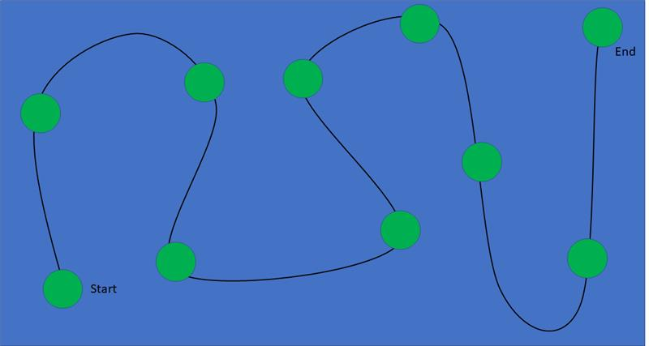

*Figure 3*

|  |
| --- |
| Spell Card |
| Revival of the dead |
| Choose one player who has died and revive them. This card can only be used once. |

*Figure 4*

|  |
| --- |
| Equipment Card |
| Heavy shield |
| The holder of the shield gains 3 defence, +1 combat and -1 speed. |

*Figure 5*

2.3 The Game

The game was inspired by the game Fire emblem awakening in which the player controls multiple characters and moves them across a tiled map. Each character in the game has various skills and different attributes for example, the cavalry can move more tiles than the soldiers and the clerics have the ability to use spells which the cavalry cannot. This gave us the idea to give each player a different character which would have different attributes which could benefit the team differently.

2.4 Reflection

This week time was much more well managed having experienced the stress of time management already, it became easier to be able to stick to a strict time schedule in which we only spent around twenty minutes coming up with the ideas in the game before then designing the game play and the rules for the game. Sticking to the time schedule also helped us create more references such as the cards and board which would help give a visual representation to the power point so that we could explain our ideas more clearly. We also had time to internally play test our game so that we could then refine the rules which is when I came up with the idea to add in the spell cards and equipment cards as a reward system and to also help the game flow more smoothly rather than relying on pure luck.